**Unit 4 Don’t eat in class.**

**词汇精讲**

**1. arrive**

1）arrive 意为“到达”。arrive at+小地点，arrive in +大地点。

例如：

I will arrive in Beijing next week. 我下周到北京。

I arrived at the small village on a cold morning. 在一个寒冷的早晨我到达了那个小村庄。

2）arrive 后面跟地点副词here, there, home时，不需要跟介词。

例如：

arrive home 到家 arrive here 到这儿

**注意：**

arrive late for与be late for是同义短语，都表示“做某事迟到”的意思。

arrive late for 强调动作晚，be late for 侧重状态晚。

例如：Don’t arrive late for the next test.＝Don’t be late for the next test.

　　　下一次考试不要再迟到了。

**2. listen**

listen 是不及物动词，意为“听,倾听”，强调听的动作，后面接宾语时要加上介词to。

例如：

We should listen to the teacher carefully. 我们应该认真听老师讲课。

Listen! Someone is singing in the garden. 听! 有人在花园里唱歌。

**拓展：**

hear, listen和sound的辨析

三个词都有“听”的意思，具体区别如下：

hear 意思是“听说，听到”，侧重听到的内容。

例如： I heard someone cry in the next room last night.

昨晚我听见有人在隔壁哭。

listen意思是“听”，侧重听的动作。

例如： Listen! Someone is crying.

听！有人在哭。

sound作动词讲时是连系动词，意为“听起来”，后面跟形容词作表语，构成主系表结构。

例如：It sounds good! 听起来不错！

**3. relax**

relax 作及物动词，意为“放松, 休息，使轻松”，第三人称单数为relaxes。

例如：

You work too hard; you should relax yourself. 你工作太努力了，你应该放松一下你自己。

This song relaxes me. 这首歌使我心情舒畅。

**拓展：**

1）relaxed形容词，意为“感到轻松的”，常修饰人做表语。

例如：He is relaxed after listening to music. 听完音乐后，他感到轻松。

2）relaxing 也是形容词，意为“令人轻松的”，常用来修饰物或者事情，可以作表语也可以作定语。

例如：It’s a relaxing trip. 这是一次令人轻松的旅行。

The film is very relaxing. 这部电影很令人放松。

**4. on time＆in time**

on time 意为“按时，准时”，指按照规定的时间或者指定的时间做某事；而in time指“及时”，指不迟到或在规定的时间之前或者接近所规定的时间做某事。

例如：

We must arrive there on time. 我们必须按时到达那里。

At last, the police arrived there in time. 最后警察及时赶到了那里。

**5. wear, put on, dress＆in**

1）wear是动词，它的意思是“穿”，它表示状态。

例如：My father wears a T-shirt today. 我爸爸今天穿着T恤衫。

2）put on的意思是“穿上、戴上”，它表示动作。

例如: It’s cold outside, put on your coat please. 外面非常冷，请穿上你的大衣。

3）dress 作动词时，表示“为……穿衣”后接反身代词或人，也可以不接宾语。

例如：Can you dress the baby for me? 你能帮我给孩子穿衣服吗？

4）in 表示穿着的状态，后接颜色或服装。

例如：The girl in red is my sister. 穿红衣服的女孩是我姐姐。

The girl in hat is very beautiful. 戴帽子的女孩儿很漂亮。

**6. strict**

strict 形容词，意为“严厉的，严格的”，在句子中可以做表语、定语。常用短语be strict with sb. 意为“对某人要求严格”；be strict in sth. 意为“对某事要求严格”。

例如：

She is a strict teacher. 她是一个严格的老师。

She is strict with her students and strict in her work. 她对她的学生和工作要求严格。

**7. bring**

bring 动词，意为“带来；拿来”。

例如：

Bring your English book to my office. 把你的英语书带到我办公室里来。

**辨析：**bring＆take

1. bring指从别处将某人或者某物带到说话人所在的地方。

例如：

Please bring your family photo tomorrow. 明天请把你的全家福带过来。

1. take 意为“带走，拿走”时，指把某人或者某物从说话人所在地带走。

例如：

His father often takes him to the zoo on weekends. 他爸爸周末经常带他去动物园。

**8. outside**

1）outside 副词，意为“在外面”，反义词是inside。

例如：

Don’t go outside. It’s too cold. 不要到外面去，天气太冷了。

2）outside还可以做介词， 意为“在……外面”。

例如：

There is a new car outside the house. 房子外边有一辆新车。

1. outside 作名词，意为“外部，外表”。

例如：

The outside of the house is red. 这个房子的外部是红色的。

**辨析：**作副词时out 与outside的区别

|  |  |  |
| --- | --- | --- |
| out | 副词 | 意为“外出，出来”，其反义词为in。 |
| outside | 副词 | 作副词时，意为“在外面，在户外”等，其反义词为inside。 |

**拓展：**go out的用法

1. 外出，或者指“参加社交活动，外出交际或娱乐”。

例如：Mary goes out a lot on Sundays. 每逢周日，玛丽的应酬非常多。

1. 出去。

例如：Let’s go out for a walk. 让我们出去散步吧。

1. 出国，移居国外。

例如：He went out to Canada two years ago. 他两年前移居加拿大了。

1. 过时，不流行。

例如：This kind of shoes went out last year. 这款鞋去年就过时了。

**9. dish**

1） dish 名词，意为“碟，盘”，做餐具讲时，常用复数形式，其前常加the。do the dishes 相当于wash the dishes，意为“清洗餐具”。

例如：It’s your turn to do the dishes today. 今天轮到你洗碗了。

2）dish 还可用作可数名词，意为“菜肴，一道菜”。

例如：He likes cold dishes. 他喜欢凉菜。

**辨析：**dish＆plate

dish和plate都是“盘，碟”的意思，它们的区别在于：

dish 可以泛指就餐时所用的餐具，包括盘、碗、碟、杯、刀、叉等，特指较深的盘子。

例如：

Please dry the dishes and put them away. 请你把餐具擦干, 收拾好。

plate 指较平的盘子、碟子, 可用来盛汤，也可用来装菜。

例如：

Our host was very generous, heaping a plate of food to us.

主人十分慷慨, 给我们装了一盘食物。

**10. practice**

1）practice 作动词时是及物动词，意为“练习，训练”，其后可跟名词、代词或动名词做宾语。

例如：

I often practice my English in the morning. 我经常在早上练习英语。

He practices playing the piano every day. 他每天练习弹钢琴。

2）practice 作名词，意为“练习，实践”，是不可数名词。

例如：

Playing the piano needs a lot of practice. 弹钢琴需要多加练习。

Practice makes perfect. 熟能生巧。

**11. follow**

follow 动词，意为“遵循，跟随”。follow the rules 意为“遵守规则”。

例如：

You must follow the school rules. 你必须遵守学校规章制度。

**拓展：**follow常见的其他用法有：

1. 跟随，跟着。

例如：Please follow me. I’ll show you the way.请跟我走，我来给你带路。

1. 明白，领悟。

例如：You are speaking too fast and we can’t quite follow you.

你讲的太快，我们不太懂你的意思。

1. 表示“沿……而行”。

例如：follow the road 沿路而行

**12. feel**

1）feel作行为动词，意为“觉得，认为”。

例如：

How do you feel today? 今天你感觉怎样?

I feel that you will win. 我感觉你会赢。

2）feel 作连系动词，意为“感觉，摸起来”，其后跟形容词作表语。

例如：

I feel happy today. 我今天感觉很高兴。

Your hand feels cold. 你的手摸起来很凉。

**词汇精练**

**Ⅰ. 根据句意和首字母或汉语提示补全单词。**

1. We must f______ the rules in the school.

2. Today is my birthday. I f______ very happy.

3. Don’t stand o_____! Come in, please!

4. He is very lazy. He’s always l______ for school.

5. Don’t f_____ with each other.

6. －When do you a______ at school? －At half past seven.

7. Can we l______ to the music?

8. The room is very d______, so you must clean it.

9. He has to do his homework b______ dinner.

10. Do you do the d______ after dinner?

**Ⅱ. 用括号中所给单词的适当形式填空。**

1. We have to ______ (wear) uniforms to school every day.

2. Jim ______ (have) to brush his teeth before going to bed.

3. My mother often asks me to practice_______ (play) the violin.

4. Don’t ______ (bring) music players to school.

5. Don’t be_____( noise) in the library.

6. Everyone feels______ (relax) when they listen to light music.

7. The weather is ______ (terrible) hot.

8. Does Jack ______ (do) his homework on time?

9. She ______ (not like) playing basketball.

10. I have to ______ (get up) at six o’clock.

**III.选词填空。**

1. ______ (Don’t, Can’t ) cross the road when the traffic lights are red.

2. It’s cold outside. I ______ (must, have to) put on my coat.

3. This is ______ (quiet, quite) an interesting book.

4. ______ (Take, Bring) your sister here with you.

5. Our teacher is very ______ (strict with, strict in) us.

6. Don’t make so much ______ (noise, noisy). Dad is sleeping in the next room.

7. After dinner I can’t ______ (relax, relaxing, relaxed) either.

8. She likes______ ( dressing, wearing, putting on) sunglasses.

9. There is a new car ______ (out, outside) the house.

10. Speak loudly, please! I can’t ______ (hear, listen to) you clearly.

**IV. 听力链接。**

**（2015 湖北襄阳中考）**

1. When is Dick’s music class?

A. On Monday. B. On Tuesday. C. On Friday.

2. Who is Dick’s music teacher?

A. Mr. Brown. B. Mrs. Green. C. Ms. Smith.

3. What’s Gina’s favorite day?

A. Friday. B. Tuesday. C. Monday.

**参考答案**

**I. 根据句意和首字母或汉语提示补全单词。**

1. follow 2. feel 3. outside 4. late 5. fight

6. arrive 7. listen 8. dirty 9. before 10. dishes

**II. 用括号中所给单词的适当形式填空。**

1. wear 2. has 3. playing 4. bring 5. noisy

6. relaxed 7. terribly 8. do 9. doesn’t, like 10. get up

**III.选词填空。**

1. Don’t 2. have to 3. quite 4. Bring 5. strict with

6. noise 7. relax 8. wearing 9. outside 10. Hear

**IV. 听力链接。**

参考答案及听力材料：

1. B 2. B 3. A

W: Hi, Dick! How is your day?

M: It’s OK. I like Tuesday because I have music. It’s my favorite subject.

W: Why do you like music best?

M: Because my music teacher, Mrs. Green, sings well and we all like her class. And what’s your favorite day, Gina?

W: Friday. Because the next day is Saturday.

M: Haha! That’s for sure. I like Friday, too.

Questions:

1. When is Dick’s music class?

2. Who is Dick’s music teacher?

3. What’s Gina’s favorite day?

**句式精讲**

**1. Don’t arrive late for class.**

1）这是一个表示否定的祈使句，祈使句表示请求、命令或者建议。谓语动词用原形，句子的主语you通常省略。句子结尾用句号，表示强烈语气的时候用感叹号, 朗读时要用降调。可以在句末或者句首加上please, 使语气更加的缓和客气。please 放在句首时后面不需要加逗号，放在句末时后面要加逗号。

例如：

Listen to your teacher, please. 请听你的老师讲话。

　 Don’t look out of the window. 不要向窗外看。

Please come in. = Come in, please. 请进。

2）这种祈使句的肯定式是“Do (实义动词) + 其他成份”。

例如：

Listen to me carefully! 认真听我讲！

Open the door! 打开门！

**2. …help his mother make breakfast.**

help sb. (to) do sth. 意为“帮助某人做某事”，help 后面可以跟带to的不定式（to+动词原形）做宾语补足语，也可以跟不带to的动词不定式（动词原形）做宾语补足语。

例如：

He often helps me (to) clean the classroom. 他经常帮助我打扫教室。

**拓展：**help既可以做动词也可以是名词，常见的其他用法有

1）help sb. with sth. 意为“帮助某人做某事”，with后可以跟名词。

例如：

I often help him with his lessons. 我经常帮他做功课。

2）with one’s help 意为“在某人的帮助下”。

例如：

With my teacher’s help, I passed the exam. 在老师的帮助下，我通过了考试。

3）help oneself to… 意为“请随便用……”。

例如：

Please help yourselves to some fish. 请随便吃些鱼吧。

**3. I have to keep my hair short.**

“keep +sb./sth.+形容词”表示“使某人或者某物保持某种状态”。此句式中的keep是动词，意为“保留，保存，保持”。

例如：

Too much work keeps me busy and tired. 太多的工作让我忙碌而且疲惫。

We must keep the class clean. 我们必须保持教室干净。

**拓展：**keep常见的其他用法

1）“keep + 形容词”，意为“保持某种状态”。

例如：Keep quiet, please! 请保持安静!

2）“keep sb. doing sth.”表示“让某人继续/不断地做某事”。

例如：He kept me waiting for an hour. 他让我等了一个小时。

**4. …because I have to/must learn to play the piano.**

此句中的learn是及物动词，意为“学习，学会”。“learn（how）to do sth.”意为“学会，学习（如何）做某事”。

例如：

You must learn (how) to drive a car. 你必须学会怎样开车。

Last year, I learnt how to swim. 去年我学会了游泳。

**拓展：**learn 的其他用法

1）learn from 意为“向……学习”。

例如：We must learn from Lei Feng. 我们必须向雷锋学习。

2）learn by oneself 意为“自学”。

例如：He learns English by himself. 他自学英语。

3）用于某些谚语中。

例如：It’s never too old to learn. 活到老，学到老。

**5. Don’t leave the dirty dishes in the kitchen!**

1）leave 作动词，意为“留下，搁置，不马上做，不马上处理”。“leave sth./sb. + 地点” 可以表示“把某人/某物留在或者落在某地”。“leave sth./sb. + 时间”可以表示“把某事搁置到某时”。

例如：

I left my pen in the classroom. 我把钢笔落在教室了。

John always leaves his dirty clothes in his bedroom. 约翰总是把他的脏衣服留在卧室。

He often leaves the things till next day. 他总是把事情留到第二天。

**注意：**leave sb. by oneself 意为把某人独自留下

例如：

They are busy with work and always leave their son home by himself.

他们忙于工作并且总是把他们的儿子独自留在家里。

2）leave 还可用在及物动词或者不及物动词表示“离开，出发”，“leave for”意为“出发去某地”。

例如：

The plane leaves for Beijing at 2 p.m.. 飞机下午两点起飞去北京。

Mr. Smith left two minutes ago. 史密斯先生两分钟前离开了。

**句式精练**

**Ⅰ. 仔细阅读对话，选择方框内的句子填空格，使对话意思连贯正确。**

|  |
| --- |
| A：there are many rules in our school.  B：You are welcome.  C：Excuse me. Where are you from?  D：Yes, you are right.  E：Can we listen to music in the classroom?  F：No, thank you.  G：Sorry, we can’t. |

A： 1 ?

B: I am from Canada. And my name is Alice.

A: Welcome. Well, 2 . Do you know them?

B: Oh, no. Can you tell me, please?

A: OK!

B: Do we have to wear a uniform every day?

A: Yes, we do.

B: 3 ?

A: No, we can’t. But we can listen to it outside.

B: Can we watch TV on school nights?

A: 4 .

B: Do we have to go to bed by 10:00 at night?

A: Yes, we must.

B: Oh I see. Thank you very much.

A: 5 .

**Ⅱ. 句型转换，每空一词。**

1. We can’t listen to music in the room. (改为祈使句)

________ ________ to music in the room.

2. Eat in class, please. (改为否定句)

_______ _______ in class, please.

3. You can practice your piano every day. (改为同义句)

_______ _______ your piano every day.

4. They have to clean the classroom every day. (对划线部分提问)

_______ _______ they have to _______ every day?

5. She has to wash clothes every week. ( 改为一般疑问句)

_______ she______ ______wash her clothes every week?

6. We must wear uniforms on Monday. （改为同义句）

We ______ ______ wear uniforms on Monday.

7. She has to get up at six o’clock every morning. ( 改为否定句)

She ______ _______ _______ get up at six o’clock every morning.

8. I have to practice my violin on Sundays. (对划线部分提问)

_______ _______ you have to practice your violin?

9. late, can’t, arrive, for, we, school（连词成句）

________________________________________.

10. There is one thing you can do. (改为复数形式)

There ______ _______ _______ you can do.

**III. 根据汉语意思，完成句子，每空一词。**

1. 你们在图书馆必须保持安静吗？

Do you _______ _______ _______ _______ in the library?

2. 你的作文里语法错误太多了。

________ ________ ________ ________ grammar mistakes in your composition.

3. 我妈妈说做完作业以前不能看电视。

My mom says I ______ watch TV _______ I finish my homework.

4. 周末她得帮妈妈干家务。

_______ weekends, she _______ _______ help her mum _______ some housework.

5. 上课不能迟到，也不能打架。

_______ arrive ______ ______ class or _______ in class.

6. 在周末，我不得不打扫自己的房间和清洗餐具。

On weekends, I _______ _______ clean my room and _______ ______ ________.

7. 外面的世界很精彩。

The _______ _______ is very wonderful.

8. 我们的数学老师对我们要求严格。

Our math teacher _______ ______ ______us.

9. 不要把脏衣服留在卧室里！

_______ _______ the _______ clothes _______ the bedroom!

10. 我必须学会说英语。

I _______ _______ ________ ________ English.

**IV．根据图片及英文提示，给每幅图写出一个适当的句子。**

**（2015 海口琼州期中）**

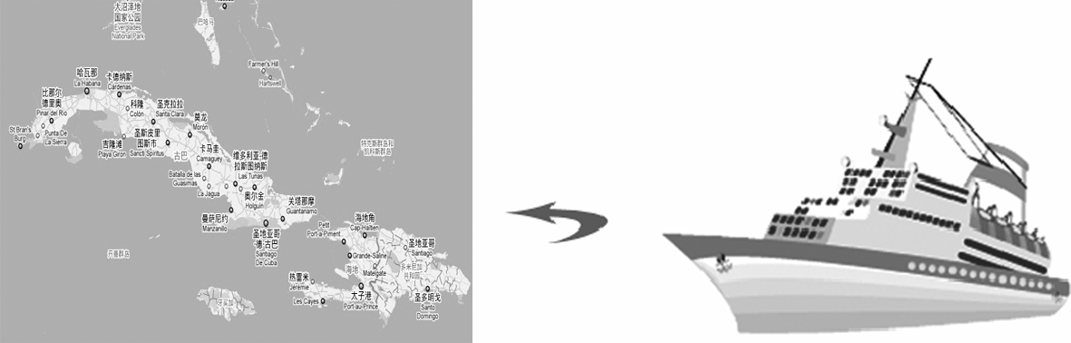

1. Maria, go, Cuba, ship, often

_______________________________________

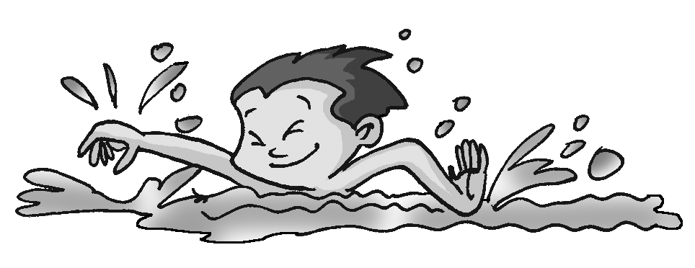

2. Bill, swimming pool, now

—________________________________

—Yes, he is.

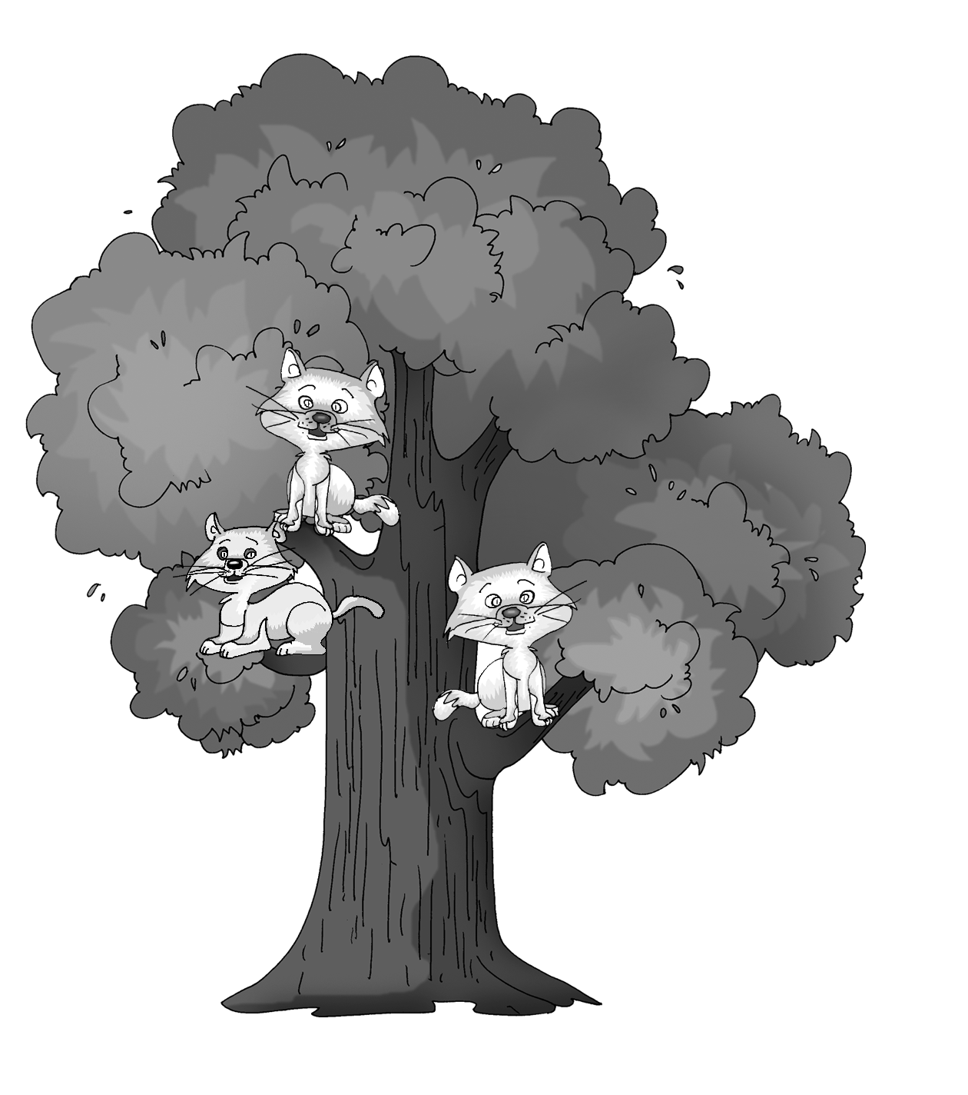

3. three cats, tree

__________________________________

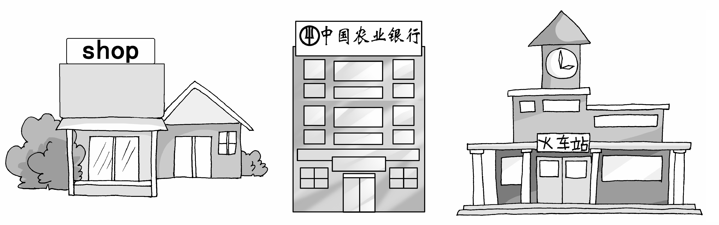

4. between … and …

__________________________________



5. What does the sign mean?

It means “_________________________”.

**参考答案**

**Ⅰ. 仔细阅读对话，选择方框内的句子填空格，使对话意思连贯正确。**

1-5：CAEGB

**Ⅱ. 句型转换，每空一词。**

1. Don’t listen 2. Don’t eat 3. Practice playing 4. What do, do 5. Does, have to

6. have to 7. doesn’t have to 8. When do 9. We can’t arrive late for school.

10. are some things

**III. 根据汉语意思，完成句子，每空一词。**

1. have to keep quiet 2. There are too many

3. can’t, before 4. On, has to, with

5. Don’t, late for, fight 6. have to, do the dishes

7. outside world 8. is strict with

9. Don’t leave, dirty, in 10. must learn to speak

**IV．根据图片及英文提示，给每幅图写出一个适当的句子。**

1. Maria often goes to Cuba by ship.

2. Is Bill swimming in the swimming pool now?

3. There are three cats in the tree.

4. The bank is between the shop and the train/railway station.

5. No right turn.